PARENTPAY CLUBS
A GUIDE FOR PARENTS

A STEP-BY STEP GUIDE TO BOOKING AND PAYING FOR KIDS’ CLUB FROM SEPTEMBER 2025 ONWARDS

1. Getting Started

How to access ParentPay Clubs

From a browser window type https://www.parentpay.com in the search bar. Log in to your ParentPay account and select the child for whom you want to make a booking.
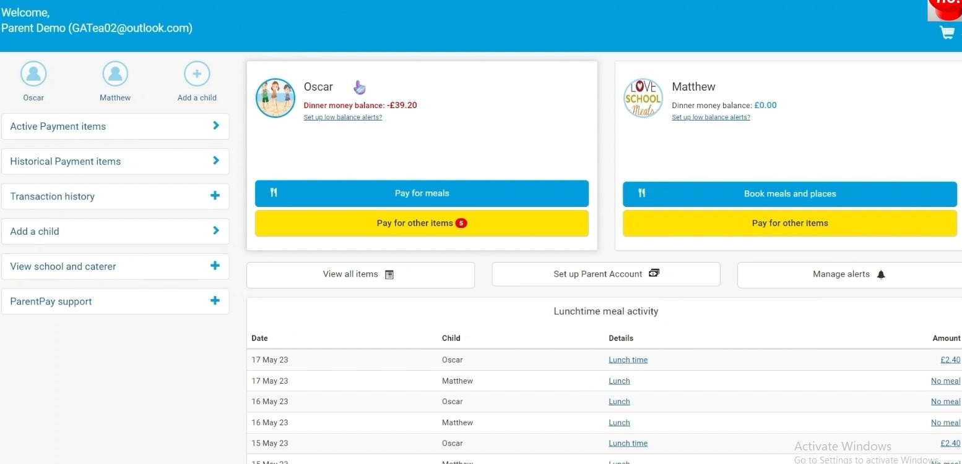

Once the child’s page has displayed, click the ‘Clubs’ option from the left-hand menu.
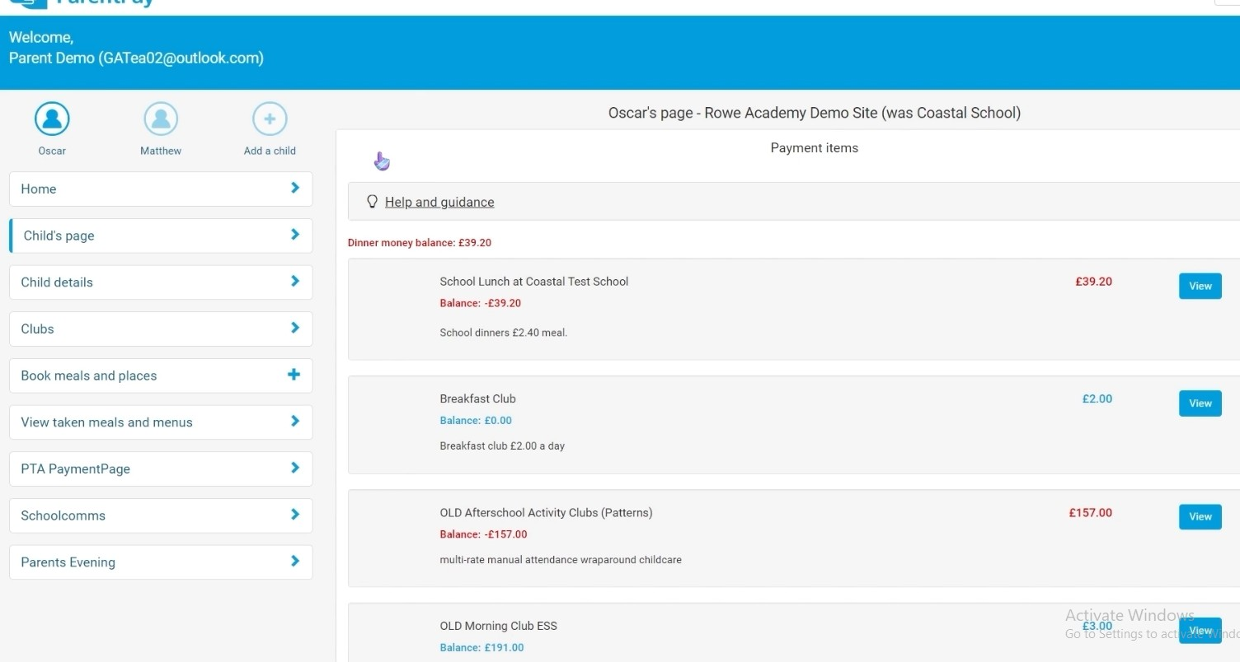

Which Clubs can I book for my child?

You will now see which clubs are available for your child to book. For Shirley Heath the only clubs currently available are Kids’ Club before school and Kids’ Club after school.

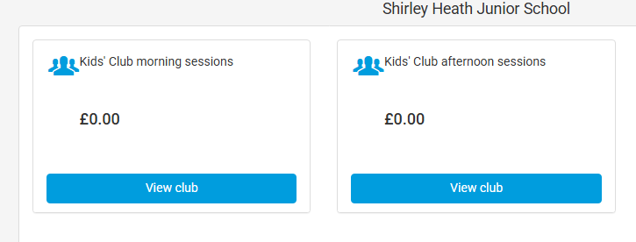
Club Balances

£0 balance
The figure showing beneath each club title indicates the current balance for that club. If the value is £0 that indicates nothing is owing.
Negative balance
A negative balance indicates a charge or booking has been made by the school. Charges are applied for late pick-ups. These are applied at a rate of £5 for every 10 minutes’ delay in collecting a child.
Bookings can be made by the school if a child were to attend Kids’ Club without a prior booking by a parent. For example, an on the day request would have to be booked through us via email or the School office.
Positive balance
A positive balance indicates that a credit has been added to your account and not currently being used for a booking. This could be if you have paid more than you needed to that month or we have refunded a session that was previously paid for and is covered under our cancellation policy.
Kids’ Club management will endeavour to review bookings for our club on a weekly basis to apply any refunds/charges or bookings necessary.

2. Support using the new system

As with any new system it may take some time to become familiar with how things work. We hope this guide will answer most of the common questions that may arise, but please use the following means to allow us to support you further:
- For technical support using the system and for general queries please call the office on 0121 7441339 or email 46office@shirley-heath.solihull.sch.uk

- For queries regarding charges or bookings, parents can use the s46kidsclub@shirley-heath.solihull.sch.uk email address.

- Parents do not need to call the office to make advance bookings for their child into Kids’ Club. Simply complete the booking via the ‘Clubs’ menu within ParentPay.

3. Making a Booking

From the ‘Clubs’ menu, click ‘View Club’. The calendar for Kids’ Club will display the dates available for booking. Select each date that you wish to book by clicking on it and then select the session you require for that day. Once selected dates will display with an orange-coloured background.
The top right corner of the screen will show the number of sessions selected and the total cost. When you are finished, click ‘Book selected sessions’. Located in the bottom right corner.
Using the ParentPay system means parents have the flexibility of booking sessions for Kids’ Club 2 weeks in advance. If you are trying to make a booking less than two weeks in advance, you will need to contact the school office or Kids’ Club to make this last-minute booking. For bookings in September 2025 only, the two weeks' notice will not apply. You can book a session for the start of September up to and including 30th August.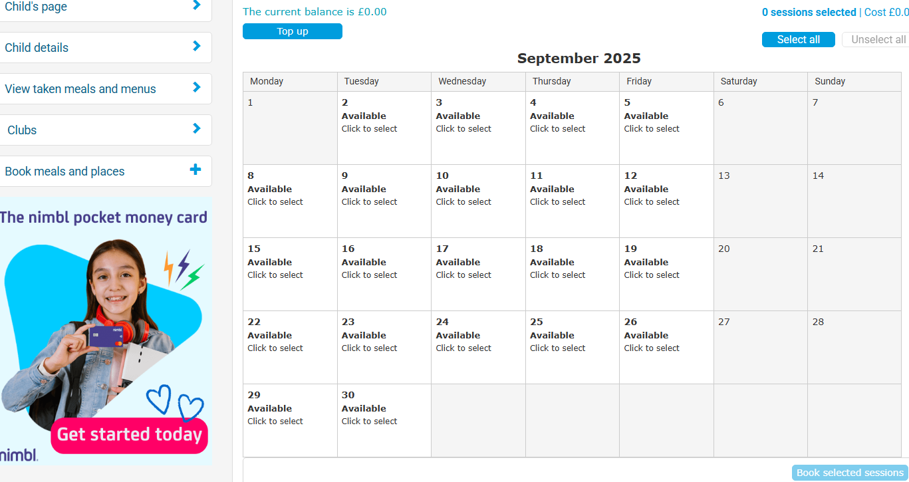

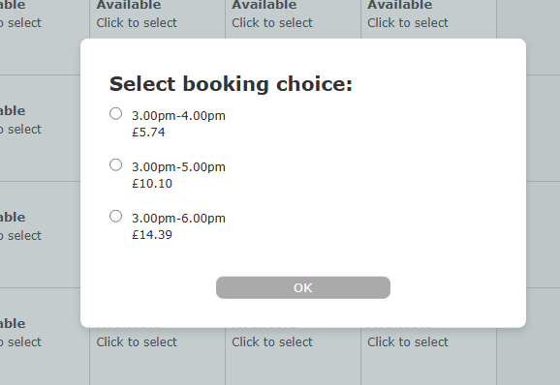

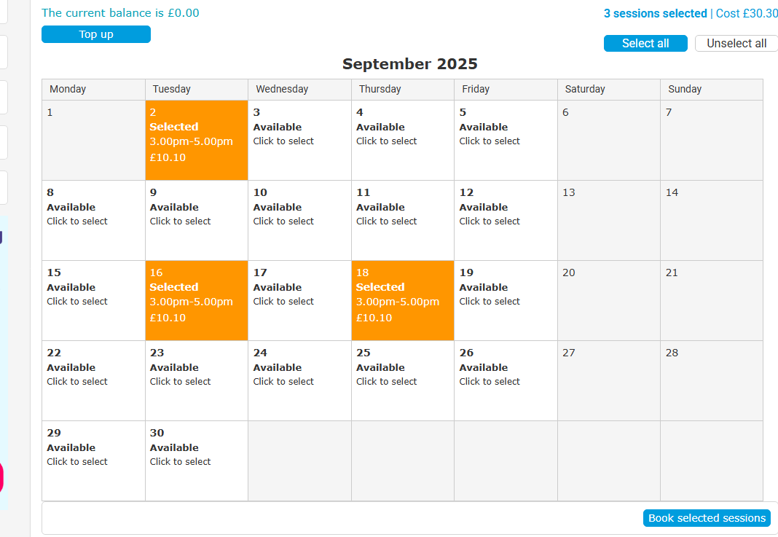

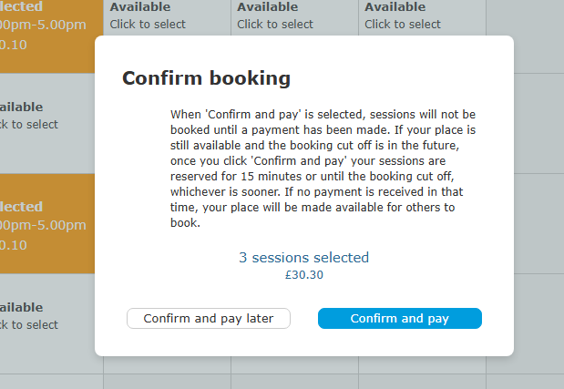
Parents who pay via voucher please select ‘Confirm and pay later’ to allow us time to verify voucher payments, information about how to tell us you have paid via voucher are below in section 4. If paying via ParentPay please select ‘Confirm and pay’.
For morning sessions, you will not get an option of time slots, the days you select will automatically charge for a breakfast session and highlight in orange as below
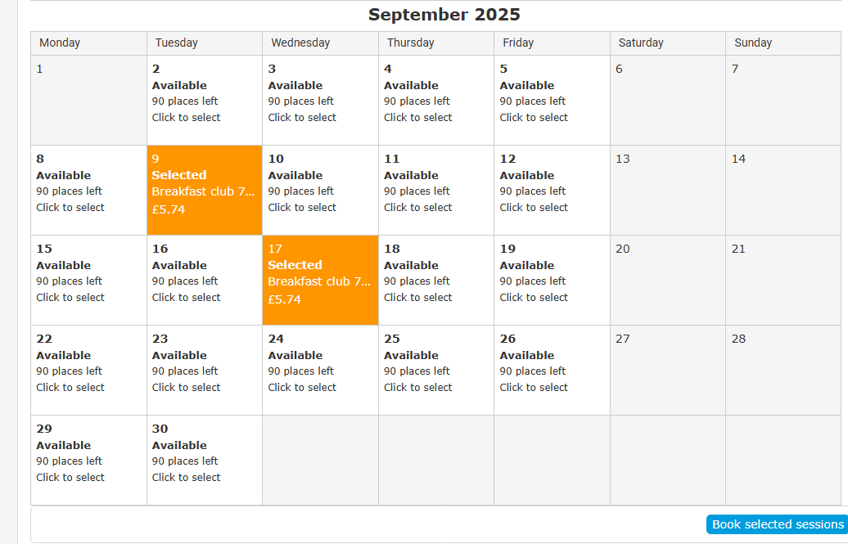

There is a 15-minute window for payment to be made to secure your child’s place on the club.
Parents can add multiple bookings from one or more children to their basket but must complete the payment within the 15 minutes since the first item was added to the basket.
See the below payment section for the payment procedure.

4. Payment

Parents may choose to make payment by debit or credit card or by using the ‘One-click payment’ option.
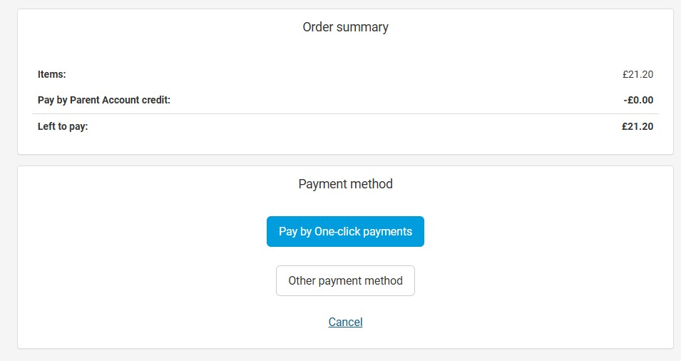
Debit/credit card payments

Select ‘Other payment method’ to pay by debit or credit card. Following a debit or credit card payment the transactions are completed immediately, and the status of the payment item will be ‘Paid’.
One-click payment option

This method of payment sets up a link between the ParentPay account and the payer’s bank account. On first use, the payer enters their bank account details and gives permission for a direct debit to be set up. This initial process can take up to 10 days to complete.
Each time the payer selects ‘One-click payment’ to purchase an item, an instruction is sent to the payer’s bank account to retrieve the funds.
Each transaction can take up to 3 days to complete and until the funds have been received by ParentPay, the status of the payment item within ParentPay will be ‘Pending’. If there are insufficient funds within the bank account, then the payment will fail, and the status of the payment will be ‘Failed payment’. Parents will need to ensure that funds are available and make a new payment to cover the item.
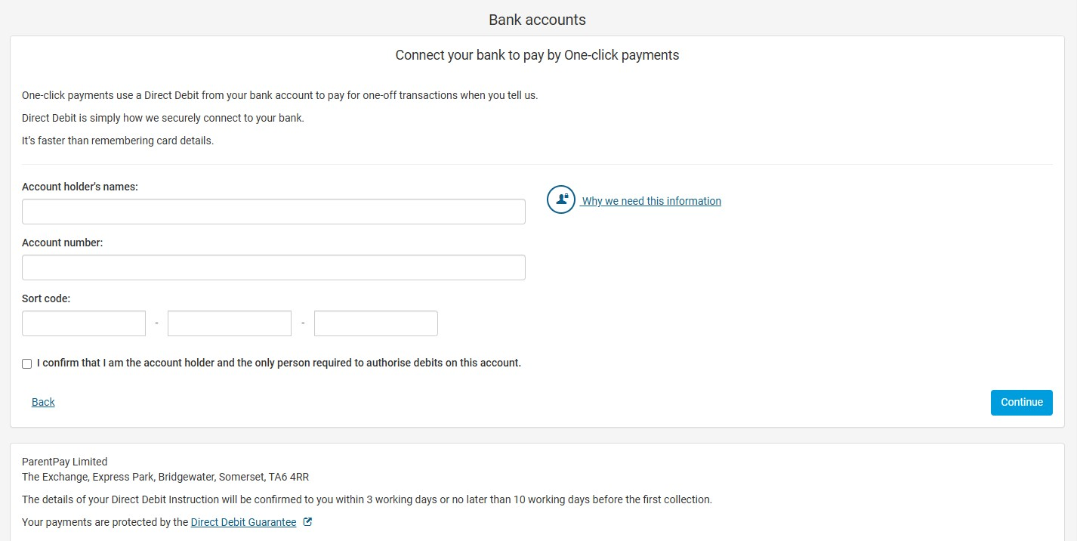

15 Minute Payment Window

Payment must be completed within 15 minutes for each individual club booking. Dates selected are reserved and become bookings once payment has been made.
It is advisable to have identified in advance the dates you wish to book for each club to ensure the booking process can be completed within 15 minutes.
This is most relevant to the bookings for the After School Club, as for each date selected you must also select a booking option.
If during the payment process you see one of the items appear greyed out, with the blue information symbol beside it and clicking the symbol reveals the wording ‘Reserved session(s) has expired’, then the system is telling you that the 15-minute payment window has passed for that item and it will need to be re-booked.
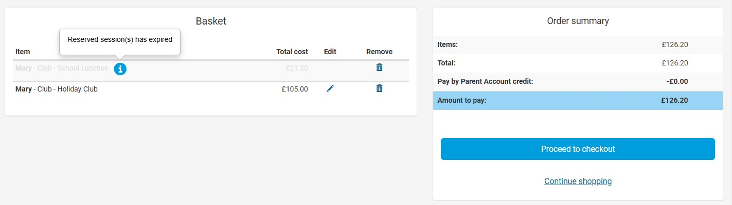
In which case, you will need to remove that item from your basket to complete the payment process for the remaining bookings. Then you will need to go back to the Club in question, re-select the dates to be booked and complete a separate payment process for that booking.
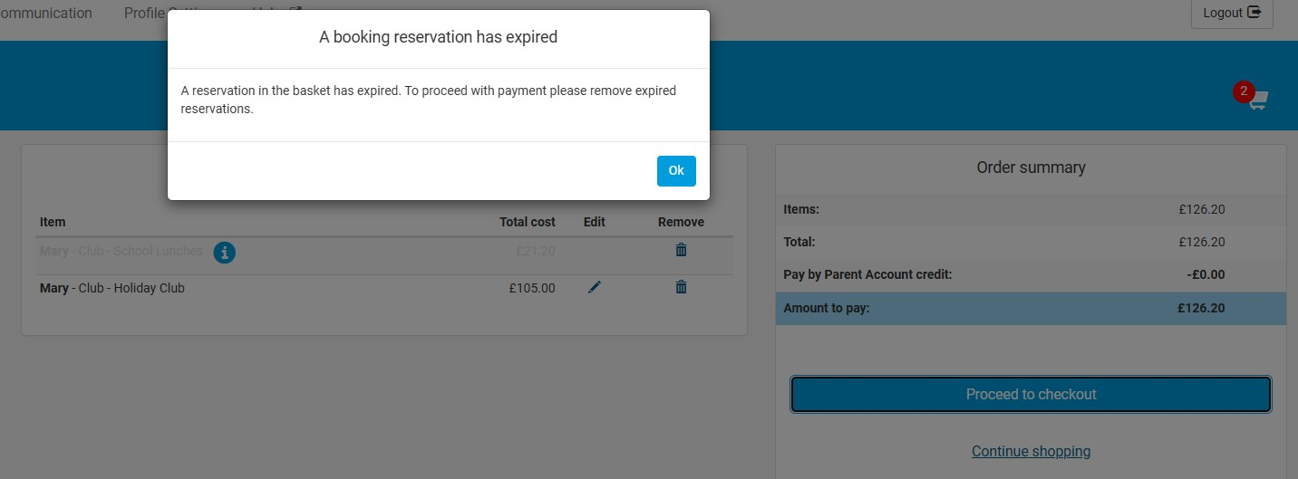

Voucher and Tax-Free Childcare payments

To pay via a Childcare Voucher or TFC on ParentPay Clubs follow the below instructions -
- Book the required sessions on ParentPay Clubs as above.
- Click ‘Confirm and pay later’ as a payment option.
- Complete the checkout process on ParentPay.
- For TFC Log onto your government gateway account and pay the amount needed to cover the cost of the booked sessions.
- For other vouchers follow your normal procedure to pay for your childcare.
- Email the details of your payment provider, date of payment and amount paid to s46kidsclub@shirley-heath.solihull.sch.uk so that the payment can be verified. Allow 7 days for this payment to be processed and added to your ParentPay account.

5. Invoices
If any family require an invoice for their reference, for UC or for any other benefit, please contact us via email at s46kidsclub@shirley-heath.solihull.sch.uk and we can ensure one is emailed to you for the sessions that have been paid for.

6. Cancellations and amendments to booked sessions
Sessions cannot be cancelled with less than 4 weeks’ notice. By using ParentPay clubs, we are not booking the whole year in for you as we previously did. You will book the sessions you require each month, so you have the flexibility to change the days you book where required.
If you require a one-off change to an already booked session, please either speak to Sarah or Amanda, or alternatively email s46kidsclub@shirley-heath.solihull.sch.uk with the details of the required change, and we can check if we can accommodate this change within our numbers and let you know.

7. Other information
When will you be able to book?
We will open each month at a time below is a table with dates for your reference -
Month to be booked | Date the booking system will open | Date the system will close
September 2025 | 4th July 2025 | 30th August 2025
October 2025 | 2nd September 2025 | 17th September 2025
November 2025 | 19th September 2025 | 17th October 2025
December 2025 | 20th October 2025 | 17th November 2025
January 2026 | 21st November 2025 | 18th December 2025
February 2026 | 19th December 2025 | 18th January 2026
March 2026 | 19th January 2026 | 15th February 2026
April 2026 | 16th February 2026 | 18th March 2026
May 2026 | 20th March 2026 | 17th April 2026
June 2026 | 20th April 2026 | 18th May 2026
July 2026 | 22nd May 2026 | 17th June 2026
September 2026 | 3rd July 2026 | 30th August 2026

Thank you!
We hope that this guide has explained the new process for Kids’ Club bookings from September 2025, however if you have any questions, please speak to either Sarah or Amanda and they will be happy to help where they can.

The booking system for September 2025 bookings will open on Friday 3rd July 2025 for current children. We will book sessions for new starters to Shirley Heath, and these will need to be paid by the Friday 5th September.

We thank you all for your continued support.

