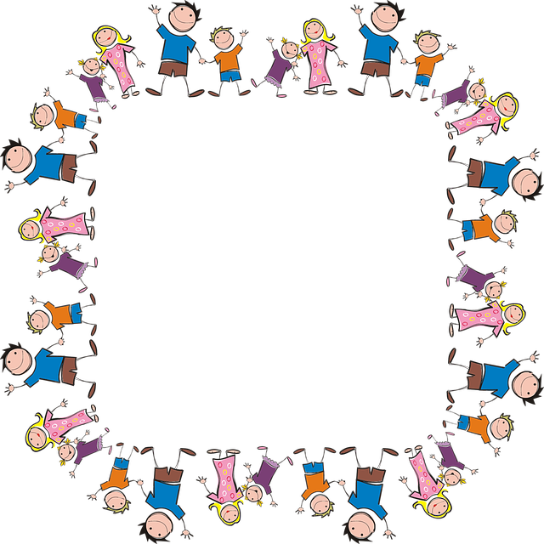
Kids’ Clubs Craft Activities

Date | Craft | Staff
1/6/2026 | Squishy ice cream | Claire
8/6/2026 | Fish Squishy | Amanda
15/6/2026 | Father’s Day | Joanna
22/6/2026 | Seagulls | Laki
29/6/2026 | Sun Catchers | Armi
6/7/2026 | Yarn Monsters | Steph
13/7/2026 | Free Craft – Children’s Choice | Sarah

